**23CSE111**

**OBJECT ORIENTED PROGRAMMING**

**LAB REPORT**



**Department of Computer Science Engineering**

**Amrita School of Computing**

**Amrita Vishwa Vidyapeetham, Amaravati Campus**

**NAME :G. Manideep**

**Verified By Roll No: AV.SC.U4CSE24108**

**INDEX**

|  |  |  |  |  |
| --- | --- | --- | --- | --- |
| **S.No.** | **Experiment Name** | **Page No.** | **Remarks** | **Signature** |
|  | **WEEK-1** |  |  |  |
| 1 | Installation Process of JDK | 3 |  |  |
| 2 | Simple Java Program for printing basic details of student | 5 |  |  |
|  | **WEEK-2** |  |  |  |
| 1 | Write a Java Program to find the factorial of a number | 7 |  |  |
| 2 | Write a Java Program to find the Fibonacci Series of given length | 9 |  |  |
| 3 | Write a Java Program to find the temperature from Celsius to Fahrenheit | 11 |  |  |
| 4 | Write a Java Program to find the Simple Interest | 12 |  |  |
| 5 | Write a Java Program to find the area of triangle using heron’s formula | 13 |  |  |
| 6 | Write a Java Program to find the area of rectangle | 15 |  |  |
|  | WEEK-3 |  |  |  |
| 1 | Write a java program with the following instructions:  a. Create class with name car.  b. Create 4 attributes named car color, car brand, fuel type, mileage.  c. Create 3 methods named start(), stop(), service().  d. Create 3 objects C1, C2, C3.  e. Create a constructor with parameters with car color, car brand, fuel type, mileage. | 18 |  |  |

|  |  |  |  |  |
| --- | --- | --- | --- | --- |
| 2 | Create a class named bank account with methods deposit and withdraw. Where the deposit method should accepts a parameter and when this method is called the deposited amount should be added to current balance. In addition to that when a withdraw method is called it has to verify whether the withdraw amount is less than the current balance. If not display message saying that there are insufficient funds. Use the constructor to display the details of the customer (Name, Account number, IFSC code, Branch). Also create two customer objects C1, C2. | 21 |  |  |
|  | WEEK-4 |  |  |  |
| 1 | Write a Java program with a class named book. The class should contain various attributes such as title, author, year of publication, and price. It should also contain a constructor with parameters that include title, author, year of publication, and price. Create a method that displays details of the book(Display the details of 3 books that is create 3 objects and display their details) | 26 |  |  |
| 2 | Create a java program with a Class named "my class" with a static variable 'count' of int type static and initialized to zero and a constant variable 'pi' of type double initialized to 3.1415 as attributes of that class now define a constructor of my class that increments the count variable each time an object of my class is created and finally prints the final values of count and pi variables. | 30 |  |  |
|  | **WEEK-5** |  |  |  |
| 1 | Create a calculator using the operations including addition, subtraction, multiplication and division using multilevel in heritance and display the desired output. | 33 |  |  |
| 2 | Vehicle rental company wants to develop a system that maintains information about different types of vehicles available for rent. The company rents out cars and bikes and they need a program to store details about each vehicle such as brand and speed.  i. Cars should have an additional property: number of doors, Seating capacity.  ii. Bikes should have a property indicating whether they have gears or not.  iii. The system should also include a function to display details about each vehicle and indicate when a vehicle is starting.  iv. Each class should have a constructor.  Questions:  1. Which OOP concept is used in the above program? Explain why it is useful in this scenario.  2. If the company decides to add a new type of vehicle ‘Truck’, how would you modify the program?  a. Truck should include and additional property capacity (in tons).  b. Create a showTruck() method to display the truck’s capacity.  c. Write a constructor for truck that initializes all properties.  3. Implement the truck class and update the main method to create a Truck object and also create an object for car and bike subclasses. Finally display the details. | 35 |  |  |
|  | **WEEK-6** |  |  |  |
| 1 | Write a Java program to create a vehicle class with a method displayInfo(). Override this method in the car subclass to provide specific information about a car, model, fuel type, and colour using the constructor | 39 |  |  |
| 2 | Create a Java program for the scenario.  A college is developing an automated admission system that verifies student eligibility for undergraduate (UG) and postgraduate(PG) programs. Each program has different eligibility criteria based on the student's percentage in their previous qualification.  i) UG admissions require a minimum of 60%  ii) PG admissions require a minimum of 70% | 41 |  |  |
| 3 | Write a Java Program to create a Calculator class with overloaded methods to perform addition: Take the integer values a and b from the user.  i) Add two integers  ii) Add two doubles  iii) Add three integer | 44 |  |  |
| 4 | Write a Java Program to create a shape class with a method calculateArea() that is overloaded for different shapes(e.g., Square, Rectangle ). Then create a subclass Circle that overrides the calculateArea() method for a circle. | 46 |  |  |
|  |  |  |  |  |
|  | **WEEK-7** |  |  |  |
|  |  |  |  |  |
|  |  |  |  |  |
|  |  |  |  |  |
|  |  |  |  |  |

**WEEK-1**

**1) Explain the process of Installing JDK (Java Development Kit)**

**Installing of JDK (Java Development Kit):**

1. **Download JDK:**
   * Go to the Oracle JDK download page in your web browser and click on JDK-21 version which is Long term support (LTS) version.
   * Click on the download link for your operating system (Windows, macOS, or Linux).
2. **Install JDK:**
   * Once downloaded, run the installer.
   * Follow the instructions and keep clicking "Next" until it's done.

1. **Set Environment Variables (Windows):**
   * Open file explorer, then right click on This PC next select on properties then it will take you to the settings app then click on advanced system settings and then  
     click on **Environment Variables**.
   * Click **New** under **System Variables**:
     + **Set Variable name as:** java_home
     + **Variable value:** The folder address where JDK is installed (like C:\Program Files\Java\jdk-21\bin)
   * Find Path under **System Variables**, click **Edit**, and add the path of the jdk-21(C:\Program Files\Java\jdk-21\bin)  
       
     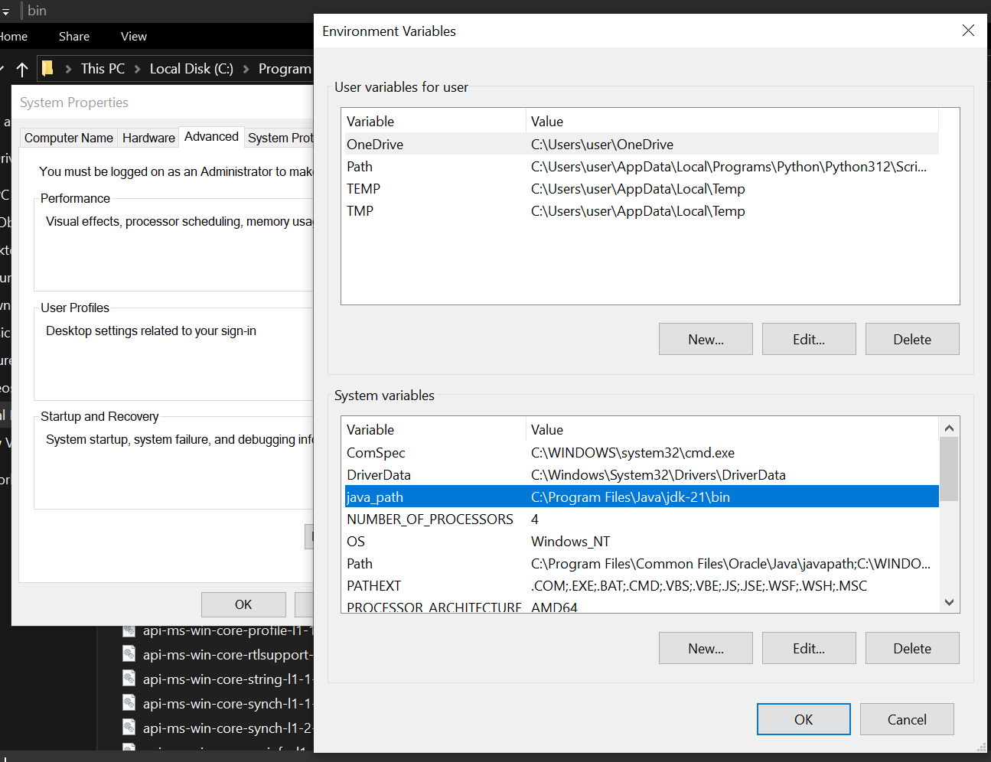

**Checking of JDK Version:**

1. **Open Command Prompt:**
   * Press win+R, type cmd, and press Enter.
2. **Check Version:**
   * Type java --version and press Enter.
   * Type javac --version and press Enter.

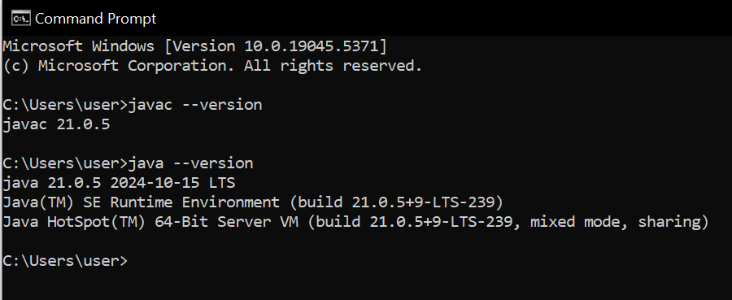

**2) Simple Java Program for printing Name, Class, Roll No, of a Student**

Write your code in Notepad and execute in cmd prompt

**CODE:**

class Main

{

public static void main(String[] args)

{

System.out.println("Name: Manideep");

System.out.println("Section: CSE-B");

System.out.println("Roll No : 24108");

}

}

**Output:**

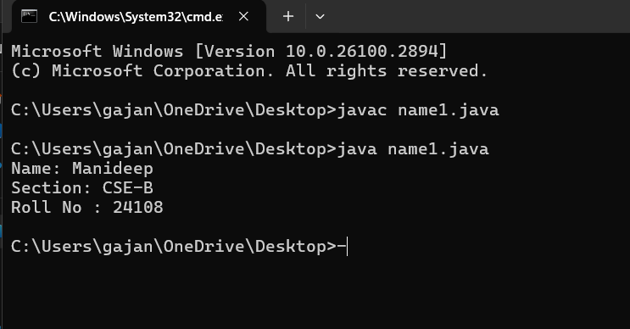

**WEEK-2**

1. **Simple Java Program for finding simple interest by taking input from User ?**

**Code:**

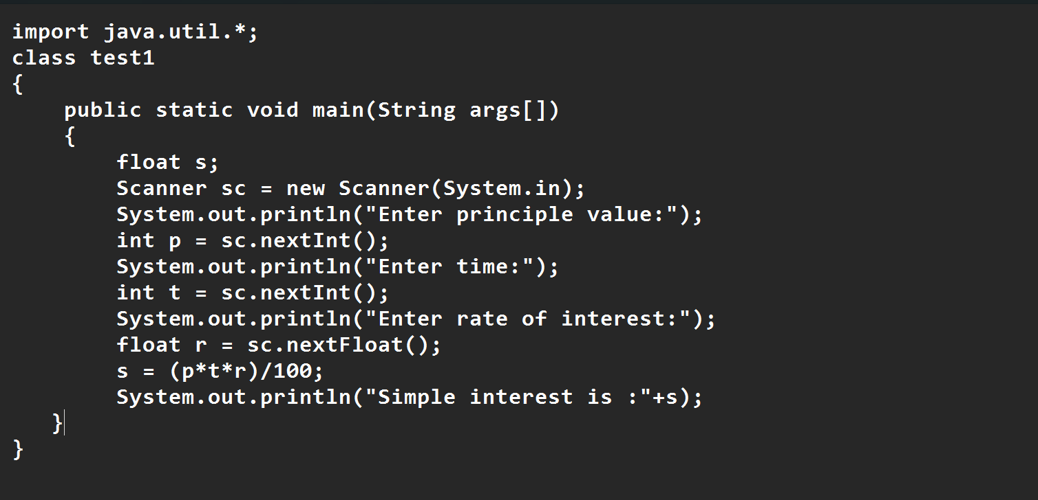

**Output:**

|  |  |  |  |
| --- | --- | --- | --- |
| S.No | Error type | Reason for error | rectification |
| 1 | Runtime error | Incorrect path | Copied correct path |
| 2 | Syntax error | { missing | { added |
| 3 | Logical error | Wrong formula | Formula rectified |

**2.Write a simple program to calculate factorial of a number and read the input from user ?**

**code:**

**Output:**

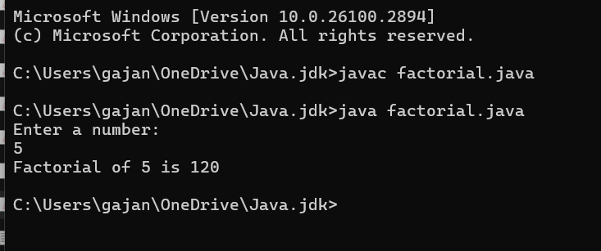

|  |  |  |  |
| --- | --- | --- | --- |
| **S.No** | **Error type** | **Reason for error** | **Rectification** |
| **1** | **Undeclared variable error** | **Missing variable** | **Variable declared** |
| **2** | **Missing import statement** | **Not importing packages** | **Packages imported** |
| **3** | **Logical error** | **Wrong formula** | **Formula rectified** |

**3.Write a program to to calculate the fibonacii sequence and take the input from user ?**

**Code:**

**Output:**

|  |  |  |  |
| --- | --- | --- | --- |
| **S.No** | **Error type** | **Reason for error** | **Rectification** |
| **1** | **Logical error** | **Incorrect formula** | **Formula rectified** |
| **2** | **Run-time error** | **Incorrect path** | **Added correct path** |

**4).Write a java program to convert temperature from Fahrenheit to celsius and take the input from user ?**

**Code:**

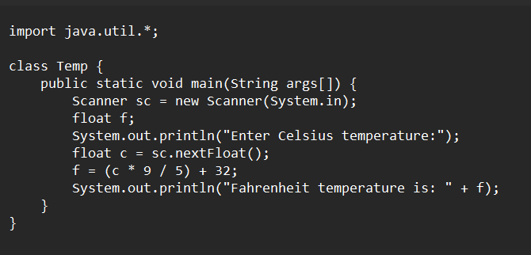

**Output:**

|  |  |  |  |
| --- | --- | --- | --- |
| **S.No** | **Error type** | **Reason for error** | **rectification** |
| **1** | **Syntax error** | **Missing ”** | **“ is added** |
| **2** | **Missing import error** | **Util package missing** | **Util package added** |

**5).Write a simple program to find the area of rectangle and take the input from user ?**

**Code:**

**Output:**

|  |  |  |  |
| --- | --- | --- | --- |
| **S.No** | **Error type** | **Reason for error** | **Rectification** |
| **1** | **Syntax error** | **Semi colon missing** | **Semi colon added** |

**6).Write a java program to convert temperature from Celsius to Fahrenheit**

**Code**

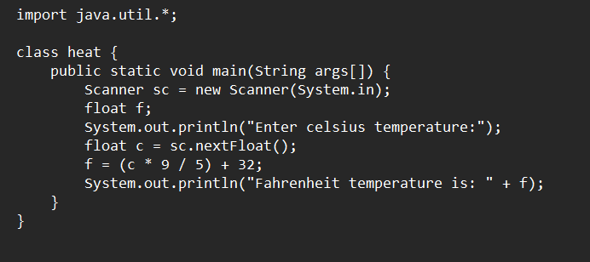

**Output:**

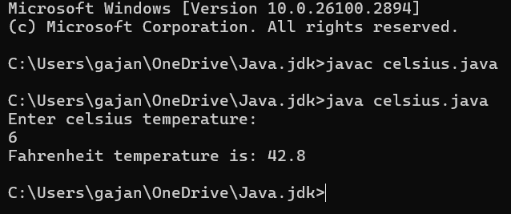

|  |  |  |  |
| --- | --- | --- | --- |
| **S.No** | **Error type** | **Reason for error** | **Rectification** |
| **1** | **Runtime error** | **Incorrect path selection** | **Correct path added** |
| **2** | **Logical error** | **Incorrect logic** | **Correct logic** |

**7).Write a program to find the area of triangle by using heron’s formula take the input from the user**

**Code:**

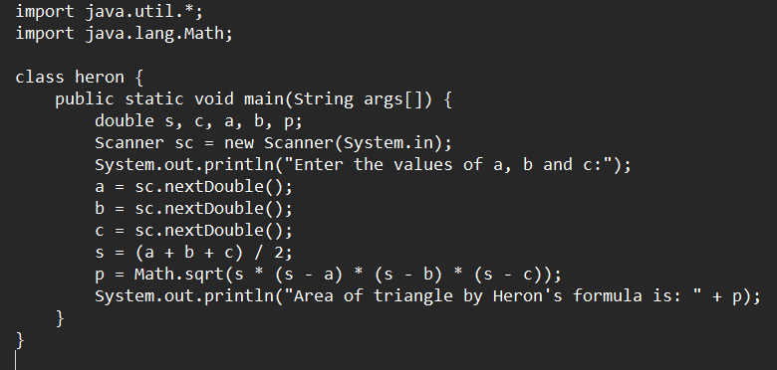

**Output:**

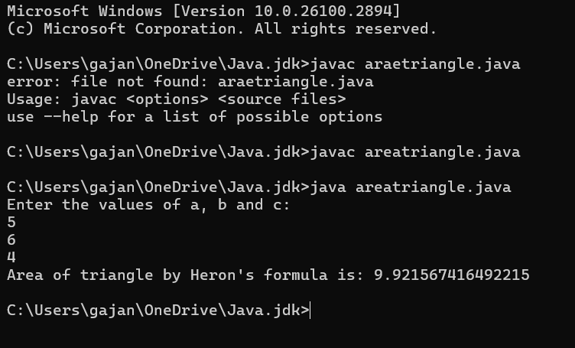

|  |  |  |  |
| --- | --- | --- | --- |
| **S.No** | **Error type** | **Reason for error** | **Rectification** |
| **1** | **Logical error** | **Incorrect formula** | **Formula rectified** |
| **2** | **Name error** | **Undeclared variable** | **Variable declared** |

**WEEK-3**

**Aim:**

**1) create a java program with following instructions**

**a.Create a class with name car**

**b. Create four attributes named car_color ,Car_brand,fuel_type,mileage**

**c. Create three methods named start(), stop(). Service()**

**d. Create three objects named car1,car2 and car3**

**2). To create a class bankAccount with methods deposit() and withdrawl ?**

**Code:**

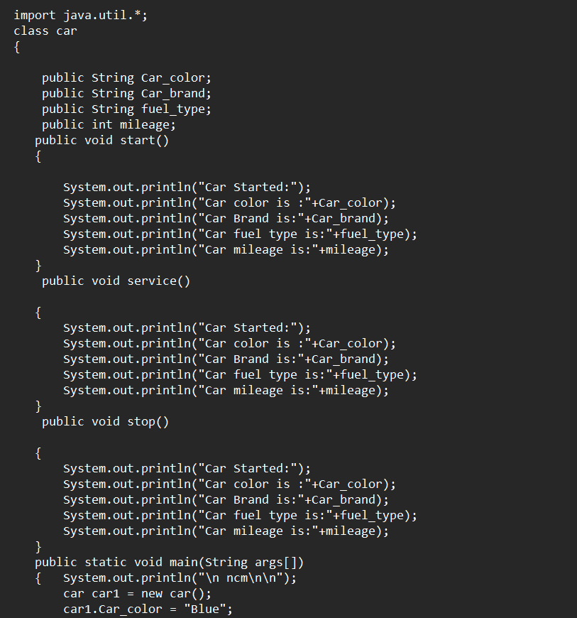

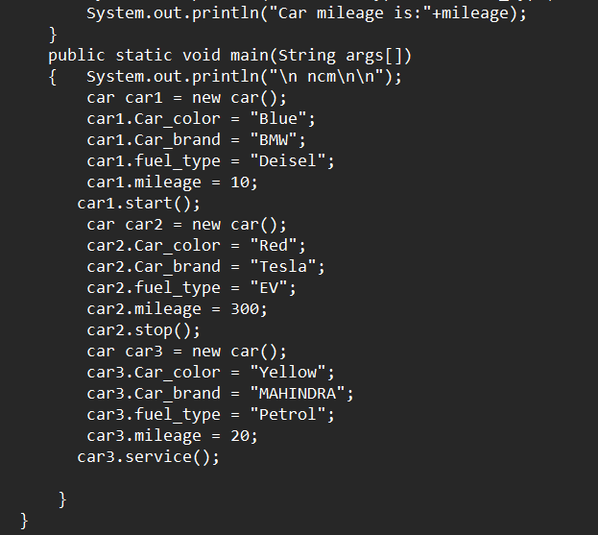

**Output:**

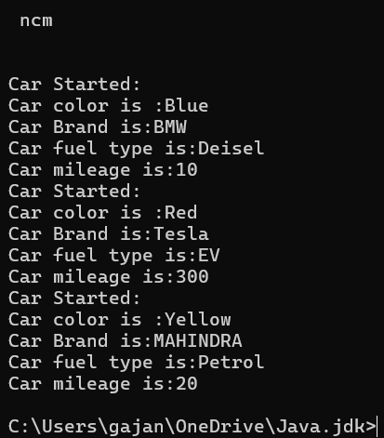

**Errors:**

|  |  |  |  |
| --- | --- | --- | --- |
| **S.No** | **Error type** | **Reason for error** | **Rectification** |
| 1 | **Name error** | **Undeclared variable** | **Variable declared** |
| **2** | **Run time error** | **Incorrect path decloration** | **Correct path declared** |
| **3** | **Syntax error** | **Semi colon missed** | **Semi colon added** |
| **4** | **Syntax error** | **Missing “** | **Added “** |
| **5** | **Syntax error** | **Int missing** | **Int added** |

**Important points:**

* Variable name mismatch: The variable car_Color in the code should be car_color
* Incorrect variable name: car1.car_color is used when the actual variable is car1.car_Color, which will cause an error due to case sensitivity.
* Missing Semicolon: Forgetting to add a semicolon at the end of a statement will cause a compilation error.

**CLASS DIAGRAM-**

|  |
| --- |
| **car**  **-----------------------**  **-car_color:string**  **-car_brand:string**  **-fuel_type:string**  **-milage:double**  **----------------------**  **+start():void**  **+stop():void**  **+service():void** |

**2).To create a class bankAccount with methods deposit() and withdrawl ?**

**code:**

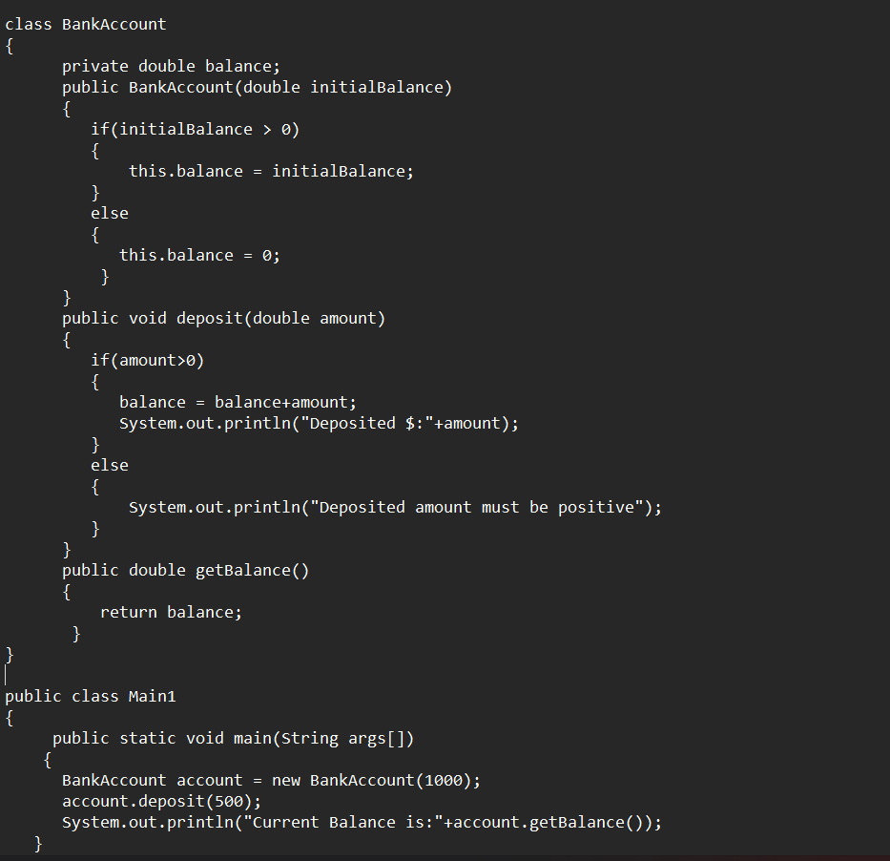

**Output:**



**Errors:**



**Important points:**

* The balance should be a float or double to handle decimal values correctly, but it's declared as an int.
* Incorrect deposit method signature: The method DEPOSIT () has an incorrect return type int(), while it should be void since it doesn't need to return any value.
* Fixed the return type of deposit: Changed from int to void, as the method does not need to return anything

**CLASS DIAGRAM-**

**WEEK-4**

**1. Write a Java program with a class named Book**

**a) a class should contain various attributes such as title, author, and year of publication.**

**b) it should also contain a constructor with parameters which initialize the title, author, and year of publication.**

**c)create a method which displays the details of the book title, author, year of publication**

**Display the details of two books.**

**CODE:**

**Output:**

**Error:**

|  |  |  |
| --- | --- | --- |
| **SI.NO** | **ERROR MESSAGE** | **ERROR RECTIFICATION** |
| 1. |  |  |
| 2. |  |  |

**Important points:**

* While defining two classes for a code, we must be sure that we save both the classes in separate files.
* While defining a method we should also define a function to call that method.

**CLASS DIAGRAM-**

|  |
| --- |
| Book   * Title: String * Author: String * Year of publication: int   + Book(title: String,  Author: String;  Year of publication: int  + displayDetails( ): void |

**2). Create a Java program with a class named ‘MyClass’ with a static variable count of int type, initialized to zero and a constant variable ‘pi’ or type double initialized to 3.14 as attributes of the class. Now define a constructor for “MyClass” that increments the count variable each time an object of MyClass is created. Finally, print the final values of the count and pi variables. Create three objects and a constructor.**

**CODE:**

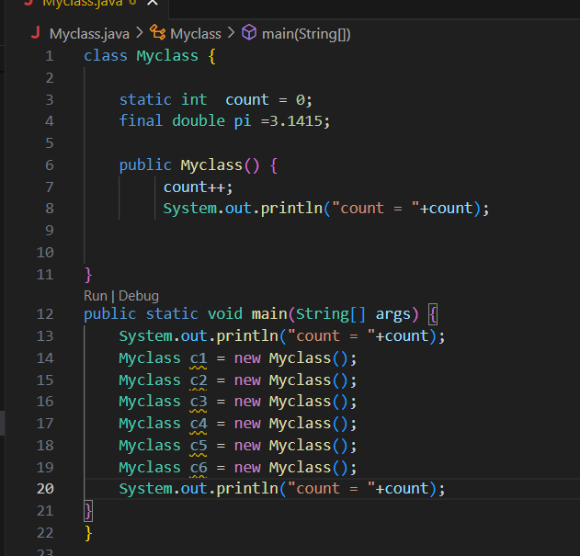

**Output:**

**Error:**

|  |  |  |
| --- | --- | --- |
| **SI.NO** | **ERROR MESSAGE** | **ERROR RECTIFICATION** |
| **1.** |  |  |
| **2.** | **error: can't find primary (String []) method in class: SimpleInterestCalculator** | **Should close the string brackets []** |

**Important points:**

* **We must declare the initial value of the variable before declaring the final one.**
* **Here the main objective is to increase the count according to the number of objects we make, i.e the count increases when the no.of objects are increasing.**

**CLASS DIAGRAM-**

|  |
| --- |
| Myclass   * Count: int * Pi: double   + myclass( )  + main(args: String[]): void |

**Week-5**

**Task-1**

**Aim:** Create a calculator using the operations including addition, subtraction, multiplication and division using multilevel in heritance and display the desired output.

**Important points:**

In order to do this, we have to use inheritance concept. Here we used the multi-inheritance concept.

Syntax:

**Super class extends subclass**

Here extends is the main key word which represents the extending relation from parent class to child class.

**Program :**

import java.util.Scanner;

import jdk.jshell.execution.Util;

public class Calci {

    public void addition(int a , int b){

        System.out.println("addition :"+(a+b));

    }

    public  void diff(int a , int b){

        System.out.println("Substraction :"+(a - b));

    }

} //end

class  Calci2 extends Calci{

    public void multi(int a , int b){

        System.out.println("multiplication :"+(a*b));

    }

} // end

class Calci3 extends Calci2{

    public void divid(int a , int b){

if(b == 0){

        System.out.println("b should not be zero");     }

    else{

        System.out.println("Division :" +(a/b));

    }

    }

}//end

class Multilevel {

    public static void main(String[] args) {

        Scanner input = new Scanner(System.in);

        Calci c1 = new Calci();

        c1.addition(80, 92);

        c1.diff(80, 92);

        Calci2 c2 = new Calci2();

        c2.multi(8, 9);

        Calci3 c3 = new Calci3();

        c3.divid(80, 92);

    }

}

**Output :**

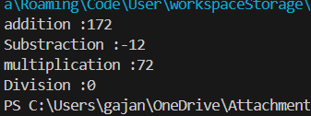

**Errors:**

|  |  |  |
| --- | --- | --- |
| **Sl.No** | **Error name** | **Error Rectification** |
| 1. | Semi colon (;) | Give the semi colon (;) in each line where it is required |
| 2. | Syntax Error | Giving Capital ‘S’ in printing statements  (System.out.println) |

**Class Diagram :**

|  |
| --- |
| **Ultimate** |
| +division (int a int b): void |

|  |
| --- |
| **Simple** |
| +addition (int a int b): void  +subtraction (int a int b): void |

|  |
| --- |
| **Advanced** |
| +multiplication (int a int b): void |

**Task-2**

**Aim:**

Task-2: A vehicle rental company wants to develop a system that maintains information about different types of vehicles available for rent. The company rents out cars and bikes and they need a program to store details about each vehicle such as brand and speed.

i. Cars should have an additional property: number of doors, Seating capacity.

ii. Bikes should have a property indicating whether they have gears or not.

iii. The system should also include a function to display details about each vehicle and indicate when a vehicle is starting.

iv. Each class should have a constructor.

Questions:

1. Which OOP concept is used in the above program? Explain why it is useful in this scenario.

2. If the company decides to add a new type of vehicle ‘Truck’, how would you modify the program?

a. Truck should include and additional property capacity (in tons).

b. Create a showTruck() method to display the truck’s capacity.

c. Write a constructor for truck that initializes all properties.

3. Implement the truck class and update the main method to create a Truck object and also create an object for car and bike subclasses. Finally display the details.

**Important points:**

Multi-inheritance: It is one of the types of the inheritance where subclass 2 inherits subclass1 and subclass1 inherits superclass. Here Vehicle is the super class or parent class and remaining cars, bikes, trucks are the subclasses or child classes.

**Program :**

class Vehicle{

        String brand;

        int speed;

        Vehicle(String brand,int speed){

            this.brand=brand;

            this.speed=speed;

        }

        void Details(){

            System.out.println("Brand:"+brand);

            System.out.println("Speed:"+speed);

        }

    }//End of super class

    class CARS extends Vehicle{

        int doors;

        int capacity;

        public CARS(String brand,int speed,int doors,int capacity){

            super(brand, speed);

            this.doors=doors;

            this.capacity=capacity;

        }

        void cardetails(){

            System.out.println("Number of doors:"+doors);

            System.out.println("Capacity:"+capacity);

        }

    }//End of car sub-class

    class Bikes extends Vehicle{

        Boolean gears;

        Bikes(String brand,int speed,Boolean gears){

            super(brand, speed);

            this.gears=gears;

        }

        void bikedetails(){

            if (gears==true)

            System.out.println("This bike has gears.");

            else

            System.out.println("This bike does not have gear system.");

        }

    }//End of bike sub-class

    class Trucks extends Vehicle{

        int tons;

        Trucks(String brand,int speed,int tons){

            super(brand, speed);

            this.tons=tons;

        }

        void truckdetails(){

            System.out.println("The capacity of truck is: "+tons);

        }

    }//End of truck sub-class

    class Rent{

        public static void main(String[] args){

            CARS c=new CARS("Mahindra",180,5,5);

            c.cardetails();

            c.Details();

            Bikes b=new Bikes("BMW",80,true);

            b.bikedetails();

            b.Details();

            Trucks t=new Trucks("TATA",100,1);

            t.truckdetails();

            t.Details();

        }

    }

**Output :**

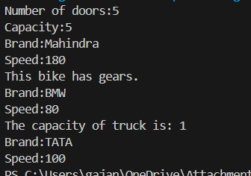

**Errors:**

|  |  |  |
| --- | --- | --- |
| **Sl.No** | **Error name** | **Error Rectification** |
| 1. | Semi colon (;) | Give the semi colon (;) in each line where it is required |
| 2. | Syntax Error | Giving Capital ‘S’ in printing statements  (System.out.println) |

**Class Diagram:**

|  |
| --- |
| **Vehicle** |
| brand: string  speed: string |
| +Vehicle(String brand, int speed)  +Details(): void |

|  |
| --- |
| **CARS** |
| doors: int  capacity: int |
| + CARS (String brand, int speed, int doors, int capacity)  +cardetails(): void |

|  |
| --- |
| **Trucks** |
| tons: int |
| + Trucks(String brand,int speed,int tons)  +truckdetails(): void |

|  |
| --- |
| **Bikes** |
| gears: Boolean |
| + Bikes(String brand, int speed, Boolean gears)  +bikedetails(): void |

**WEEK-6**

1) **Write a Java program to create a vehicle class with a method displayInfo(). Override this method in the car subclass to provide specific information about a car, model, fuel type, and color using the constructor**

- Write your code in VS CODE and execute

**- Important Points:**

* + - 1. Understand the calling of a Constructor
      2. Giving class name correctly
      3. Give the parameters Correctly

**CODE:**class Vehicle {

String Brand;

String model;

String fuel;

String color;

int capacity;

Vehicle(String Brand, String model, String fuel, int capacity, String color) {

this.Brand = Brand;

this.model = model;

this.fuel = fuel;

this.capacity = capacity;

this.color = color;

}

void displayInfo(String Brand, String model, String fuel, int capacity, String color) {

System.out.println("Vehicle Details: ");

System.out.println("Brand: " + Brand);

System.out.println("Model: " + model);

System.out.println("Fuel: " + fuel);

System.out.println("Capacity: " + capacity);

System.out.println("Color: " + color);

}

}

class Car extends Vehicle {

Car(String Brand, String model, String fuel, int capacity, String color) {

super(Brand, model, fuel, capacity, color);

}

void displayInfo() {

System.out.println("Car Details: ");

System.out.println("Brand: " + Brand);

System.out.println("Model: " + model);

System.out.println("Fuel: " + fuel);

System.out.println("Capacity: " + capacity);

System.out.println("Color: " + color);

}

}

class Week6_1 {

public static void main(String[] args) {

// Creating an instance of Car

Car car1 = new Car("BMW", "X5", "Petrol", 6, "Red");

car1.displayInfo(); // Display car details

}

}

**OUTPUT:**

**Errors:**

|  |  |  |
| --- | --- | --- |
| S.NO | Error Name | Error Rectification |
| 1 | Syntax/ Compilation Error | Absence of Semicolon |
| 2 | Closing Brackets | Need to Close the brackets |
| 3 | Class Name Error | Give the class name correctly |
| 4 | Constructor Calling | Call the constructor correctly |

**2) Create a Java program for the scenario.**

**A college is developing an automated admission system that verifies student eligibility for undergraduate (UG) and postgraduate(PG) programs. Each program has different eligibility criteria based on the student's percentage in their previous qualification.**

**i) UG admissions require a minimum of 60%**

**ii) PG admissions require a minimum of 70%**

- Write your code in VS CODE and execute

**- Important Points:**

* + - 1. Understand the calling of a Constructor
      2. Giving class name correctly
      3. Give the parameters Correctly

**CODE:**

class College{

String name;

int percentage;

void geteligibility(String name,int percentage){

this.name=name;

this.percentage=percentage;

}

}

class UG extends College{

void geteligibility(String name,int percentage){

if (percentage>=60){

System.out.println(name+" is eligible");

}

else{

System.out.println(name+" is not eligible");

}

}

}

class PG extends College{

void geteligibility(String name,int percentage){

if (percentage>=70){

System.out.println(name+" is eligible");

}

else{

System.out.println(name+" is not eligible");

}

}

}

class week6_2{

public static void main(String[] args){

UG ug=new UG();

ug.geteligibility("Person-1",40);

PG pg=new PG();

pg.geteligibility("Person-2",80);

}

}

**OUTPUT:**

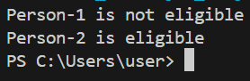

**Errors:**

|  |  |  |
| --- | --- | --- |
| S.NO | Error Name | Error Rectification |
| 1 | Syntax/ Compilation Error | Absence of Semicolon |
| 2 | Closing Brackets | Need to Close the brackets |
| 3 | Class Name Error | Give the class name correctly |
| 4 | Constructor Calling | Call the constructor correctly |

**3) Write a Java Program to create a Calculator class with overloaded methods to perform addition: Take the integer values a and b from the user.**

**i) Add two integers**

**ii) Add two doubles**

**iii) Add three integers**

- Write your code in VS CODE and execute

**- Important Points:**

* + - 1. Understand the calling of a Constructor
      2. Giving class name correctly
      3. Give the parameters Correctly

**CODE:**

class Calc{

public int add(int a,int b){

return a+b;

}

public double add(double a,double b){

return a+b;

}

public int add(int a,int b,int c){

return a+b+c;

}

}

class week6_3{

public static void main(String[] args){

Calc C1=new Calc();

System.out.println("Sum of 6 and 9 is: "+C1.add(6,9));

System.out.println("Sum of 7.6 and 8.6 is: "+C1.add(7.6,8.6));

System.out.println("Sum of 2,4 and 6 is: "+C1.add(2,4,6));

}

}

**OUTPUT:**

**Errors:**

|  |  |  |
| --- | --- | --- |
| S.NO | Error Name | Error Rectification |
| 1 | Syntax/ Compilation Error | Absence of Semicolon |
| 2 | Closing Brackets | Need to Close the brackets |
| 3 | Class Name Error | Give the class name correctly |
| 4 | Constructor Calling | Call the constructor correctly |

**4) Write a Java Program to create a shape class with a method calculateArea() that is overloaded for different shapes(e.g., Square, Rectangle ). Then create a subclass Circle that overrides the calculateArea() method for a circle.**

- Write your code in VS CODE and execute

**- Important Points:**

* + - 1. Understand the calling of a Constructor
      2. Giving class name correctly
      3. Give the parameters Correctly

**CODE:**class Shape {

double calculateArea(double side) {

return side * side;

}

double calculateArea(double width, double height) {

return width * height;

}

}

class Circle extends Shape {

double calculateArea(double radius) {

return 3.14 * radius * radius;

}

}

class Week6_4 {

public static void main(String[] args) {

Shape S1 = new Shape();

System.out.println("Area of square: " + S1.calculateArea(5));

System.out.println("Area of rectangle: " + S1.calculateArea(2, 5));

Circle C1 = new Circle();

System.out.println("Area of circle: " + C1.calculateArea(3));

}

}

**OUTPUT:**

**Errors:**

|  |  |  |
| --- | --- | --- |
| S.NO | Error Name | Error Rectification |
| 1 | Syntax/ Compilation Error | Absence of Semicolon |
| 2 | Closing Brackets | Need to Close the brackets |
| 3 | Class Name Error | Give the class name correctly |
| 4 | Constructor Calling | Call the constructor correctly |

**WEEK-7**

1. **Aim : Write a Java program to create an abstract class Animal with an abstract method called sound(). Create subclasses Lion and Tiger that extend the Animal class and implement the sound() method to make a specific sound for each animal.**

**Important points :**

1. Here we used abstract class concept it is a restricted class that cannot be instantiated (cannot have objects created directly) and is typically designed to be extended by subclasses.

2. An abstract method is a method declared in an abstract class that does not have an implementation, meaning it doesn't have a body within the abstract class.

3. Here we used hierarchy inheritance concept means every sub class extends super class.

**Program:**

abstract class animal{

    abstract void sound();

}

class lion extends animal{

    void sound(){

        System.out.println("lion roars");

}

}

class tiger extends animal{

    void sound(){

        System.out.println("tiger growls");

    }

}

class ABanimal{

    public static void main(String[] args) {

        System.out.println("NAME : Manideep");

        System.out.println("ROLL NO : 24108");

        System.out.println("SEC: CSE-B");

        System.out.println(".......................");

        lion l = new lion();

        l.sound();

        tiger t = new tiger();

        t.sound();

    }

}

**Output:**

**Error table :**

|  |  |  |
| --- | --- | --- |
| S.NO |  |  |
| 1 | Main Class | Better to create main class name same as the file you saved and first letter is capital. |
| 2 | Method | We need to provide return type to the method. |
| 3 | Data type | As per need provide data type 4 Abstract method |
| 4 | Abstract method | Implementation in subclass only |

1. Aim : Write a Java program to create an abstract class Shape3D with abstract methods calculateVolume() and calculateSurfaceArea(). Create subclasses Sphere and Cube that extend the Shape3D class and implement the respective methods to calculate the volume and surface area of each shape.

**Program:**

abstract class Shape3D {

    public abstract double calculateVolume();

    public abstract double calculateSurfaceArea();

}

class Sphere extends Shape3D {

    private double radius;

    public Sphere(double radius) {

        this.radius = radius;

    }

    public double calculateVolume() {

        return (4.0/3) * Math.PI * Math.pow(radius, 3);

    }

    public double calculateSurfaceArea() {

        return 4 * Math.PI * Math.pow(radius, 2);

    }

}

class Cube extends Shape3D {

    private double side;

    public Cube(double side) {

        this.side = side;

    }

    public double calculateVolume() {

        return Math.pow(side, 3);

    }

    public double calculateSurfaceArea() {

        return 6 * Math.pow(side, 2);

    }

}

public class  Shapees{

    public static void main(String[] args) {

        System.out.println("MAnideep");

        System.out.println( "24108");

        System.out.println( "Section B");

        Shape3D sphere = new Sphere(5);

        Shape3D cube = new Cube(4);

        System.out.println("Sphere Volume: " + sphere.calculateVolume());

        System.out.println("Sphere Surface Area: " + sphere.calculateSurfaceArea());

        System.out.println("Cube Volume: " + cube.calculateVolume());

        System.out.println("Cube Surface Area: " + cube.calculateSurfaceArea());

    }

}

**Output:**

**Error table :**

|  |  |  |
| --- | --- | --- |
| S.NO | Error Name | Error Rectification |
| 1 | Main Class | Better to create main class name same as the file you saved and first letter is capital. |
| 2 | Data type | As per need provide data type 3 Abstract method Implementation in subclass only |
| 3 | Abstract method | Implementation in subclass only |

**Important points :**

1. Here we used abstract class concept it is a restricted class that cannot be instantiated (cannot have objects created directly) and is typically designed to be extended by subclasses.

2. An abstract method is a method declared in an abstract class that does not have an implementation, meaning it doesn't have a body within the abstract class.

3. Understanding the calling of constructor.

1. **Aim :** write a java program using an abstract class to define a method for pattern printing Create an abstract class named pattern printer with an abstract method print pattern (int n) and a concrete method to display the pattern tittle. Implement two sub

class :

1.star pattern -prints a right-angled triangle of stars(*)

2.number pattern-prints a right angled triangle of increasing numbers. In the main () method,create objects of both subclasses and print the pattern for a given number of rows.

**Program:**

abstract class PatternPrinter{

    public abstract void printPattern(int n);

    public void printTitle(String title) {

        System.out.println(title);

    }

}

class StarPattern extends PatternPrinter {

    public void printPattern(int n){

        for (int i=1;i<=n;i++) {

            for (int j=1;j<=i;j++) {

                System.out.print("* ");

            }

            System.out.println();

        }

    }

}

class NumberPattern extends PatternPrinter {

    public void printPattern(int n) {

        for (int i=1;i<n;i++) {

            for (int j=1;j<=i;j++) {

                System.out.print(j+" ");

            }

            System.out.println();

        }

    }

}

public class pattern {

    public static void main(String[] args) {

System.out.println("Manideep");

System.out.println("24108");

System.out.println("CSE-B");

        int rows=5;

        PatternPrinter starPattern = new StarPattern();

        PatternPrinter numberPattern = new NumberPattern();

        starPattern.printTitle("Star Pattern:");

        starPattern.printPattern(rows);

        System.out.println();

        numberPattern.printTitle("Number Pattern:");

        numberPattern.printPattern(rows);

    }

}

**Output:**

**Error table :**

|  |  |  |
| --- | --- | --- |
| S.NO | Error Name | Error Rectification |
| 1 | Main Class | Better to create main class name same as the file you saved and first letter is capital. |
| 2 | Data type | As per need provide data type |
| 3 | Syntax | in for Initializing value and condition should be correct |
| 4 | overridding | Same method name |

**Important points :**

1. Here we used nested for loop concept the block of code is executed until the condition is false.

2. Here the logic very important .

3. Here we used abstract class concept it is a restricted class that cannot be instantiated (cannot have objects created directly) and is typically designed to be extended by subclasses.